**ECE374 Assignment 9**

Due 04/24/2023

**Group & netid**

*Chen Si chensi3*

*Jie Wang jiew5*

*Shitian Yang sy39*

**Problem 1**



Solution:

Denote a graph with an Independent Set as G, a graph with a Strongly Independent Set as H

e.g.

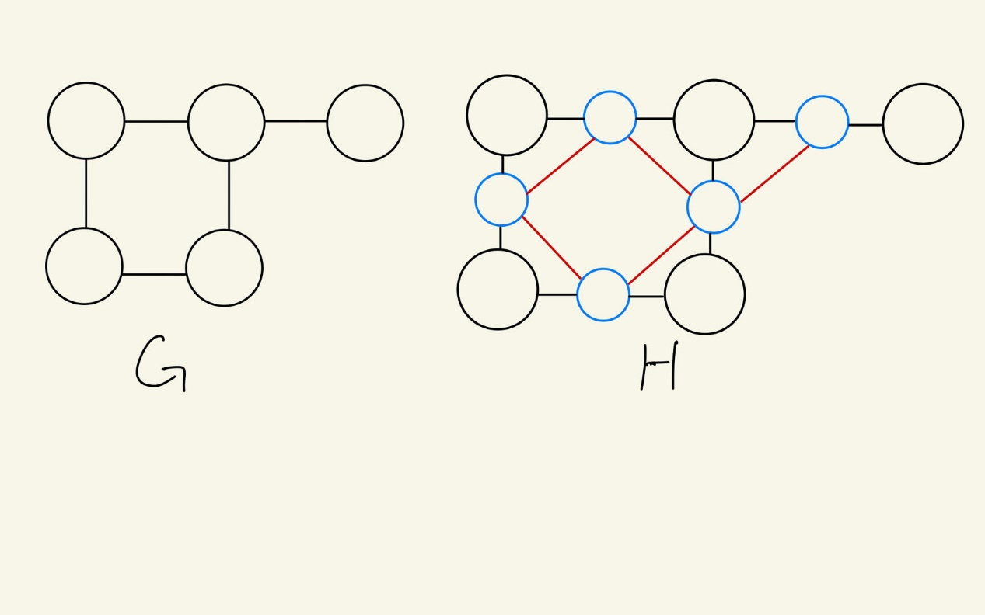

A

B

C

D

E

A

B

C

D

E

e1

e2

e3

e4

e5

We would like to build a reduction from Independent Set to Strongly Independent Set to prove that SIS is an NP-hard problem.

(1) IS 🡪 SIS

Transformation:

For a graph G with an Independent Set (e.g. Graph G in the figure above), we construct a graph H that inherits all vertices and edges from G. Then, we add “edge nodes” into H that create a node for each edge from G, labeling it as the edge weight, and connecting each pair of edge nodes whose corresponding edge shares a vertex in G (e.g. construct Graph H from Graph G).

In this case, for the Independent Set V in Graph G, in which the distance between any pair of vertices are greater than or equal to 2, we have the same set of vertices in Graph H to have distance between any pair of them greater than or equal to 3. (as shown by the example graph)

e.g. for independent set {A, C, E} in graph G, we have a strongly independent set {A, C, E} in H, such that dist_G(A, C) = 2 and dist_H(A, C) = 3.

Therefore, for a Yes instance of a graph with Independent Set, we have a polynomial time algorithm to transform it into a Yes instance of a graph with Strongly Independent Set.

(2) SIS 🡪 IS

Transformation:

For a graph H with a Strongly Independent Set (e.g. Graph H in the figure above), we could observe that for an edge node E that connects two vertices N and M that shown as N—E—M in the graph, suppose there’s a path of length *l* to E, the length of the path from the same origin to N or M would be *l*+1 or *l*. Therefore, for any path that links 2 members of the Strongly Independent Set, if one endpoint of the path is an edge node, we could divert it into a linked vertex, with *l* or *l*+1 length.

Thus, if there exists a SIS in the graph H, we could replace each “edge node” in the SIS set with a connected “vertex” of it. Then, we could eliminate all “edge nodes” and edges connecting between them to obtain a graph G. The modified SIS set from H, in which distances between every pair of nodes are ≥ 3, would now be an IS set in graph G, in which distances between every pair of nodes are ≥ 2 (based on the definition and construction of “edge nodes”, see (1)).

Therefore, we could reduce Independent Set problem to Strongly Independent Set problem. Since Independent Set problem is NP-hard, Strongly Independent Set problem is also NP-hard.